INTRODUCTION
There are a large number of calculated area fields in the ARCHIBUS Space Management module, many of which are unused in the university’s current installation. However, given the number of area fields that are used, we decided to put together this reference document that attempts to better explain the different area calculations in use at this time. The first part of the document contains boiler-plate, out-of-the-box calculation equations that we assume come directly from ARCHIBUS field definitions. The rest of the document contains a more robust exploration of the fields as they exist in our instance today, as well as some examples, cheat sheets, etc., all produced by Laurie Rees.

ARCHIBUS DEFINITIONS
The following definitions were provided by Michael Shearin, Project Manager with BRG. According to Michael, these are the out-of-the-box (OOTB) calculations provided by the ARCHIBUS software. We do not believe there were any calculation modifications made to the UT implementation, though certain terminology may have been changed.
  - Building Assignable Area (this is “Usable Area” OOTB, but was changed to suit UT terminology)
    - Rolled up from Floor Usable Area
    - Floor Usable Area = Floor Rentable – Floor Service Area
    - Floor Rentable = Floor Internal Gross – Floor Vertical Penetration

  - Building Total Room Area = SUM of Floor Total Area
    - Floor Total Area = SUM: Room Total Area (i.e. the sum of the rm.area field for all rooms on a floor)

  - Building Total Occupiable Area = SUM of Floor Occupiable Area
    - Floor Occupiable Area = SUM (Room Area) where Room Category is Occupiable

  - Building Total Non-Occupiable Area = SUM of Floor Non-Occupiable Area
    - Floor Non Occupiable Area = SUM of Room Area where Room Category is Non-Occupiable

  - Building Total Room Department Area
    - Rolled up from the Floor’s Total Room Department Area
    - Floor Total Room Department Area = Sum of Room Area where Department ID (i.e. dp_id) is NOT NULL.

  - Building Total Room Common Area = SUM of Room Area where PRORATE = ‘BUILDING’

UT DOCUMENTATION
Area Chart:
The chart below is one that Laurie put together for our reference purposes. It shows visually the relationship of areas using ARCHIBUS terms.
Internal Gross Area (area_gross_int)

Net Useable Area (area_rentable)

Total Room Area |  |  | Remaining  (Structural)
Occupiable  Sum of rooms with room categories 01.xxx |  | Non-Occupiable  Sum of rooms with room categories 02.xxx
Occupiable Dept  Assignable & Assigned | Difference  (01.xxx rooms with no responsible cost center)

Spreadsheet with Descriptions:
The following is a partial screenshot of a spreadsheet that Laurie put together of the 84 buildings we had in ARCHIBUS for Memphis as of 3/8/2013. She arranged the columns in a logical progression to help step through the calculations being done. Following the spreadsheet is a list of bulleted items further explaining the values and terms found on the spreadsheet itself. I have re-oriented the picture to make it easier to read.
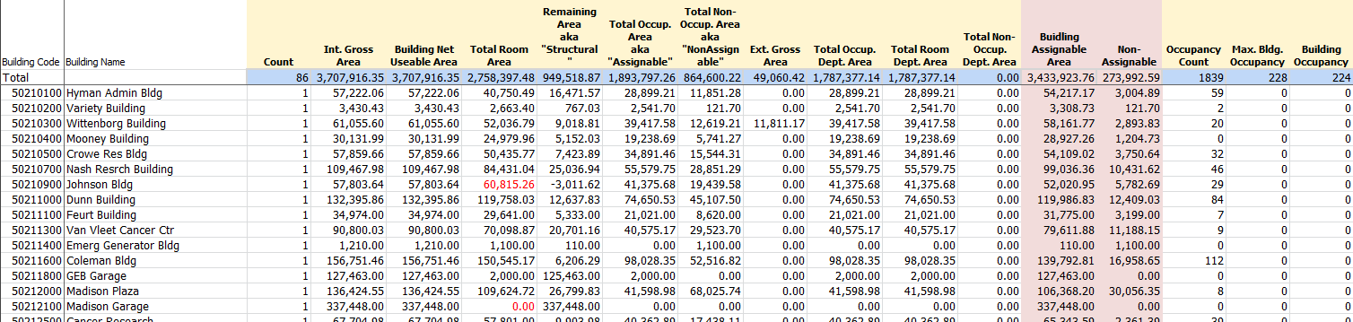

- When scanning across a row, the “Total Room Area” and the “Remaining Area” (aka “Structural”) always equal the “Int. Gross Area.”
- The “Int. Gross Area” and “Building Net Useable Area” fields always have the same values. If we had declared any of our area types as “Vertical Penetration” then these numbers would be different.
- The “Total Room Area” field is the sum of all rooms. This is often referred to in IRIS as the “net area.”
- The “Remaining Area” field is the difference between the “Int. Gross Area” and the “Total Room Area.” That is why it is also referred to as “Structural,” since it represents the structural part of the building.
- The “Total Occup. Area” field is the sum of only those rooms assigned to the 01.xxx series of room categories. This may also be referred to as the “Assignable” area.
- The “Total Non-Occup. Area” field is the sum of only those rooms assigned to the 02.xxx series of room categories. This may also be referred to as the “Non-Assignable” area.
- Columns K, L, and M (“Total Occup. Dept. Area,” “Total Room Dept. Area,” and “Total Non-Occup. Dept Area” respectively) could be of interest to us. For example, if the “Total Occup. Dept Area” does not equal the “Total Occup. Area,” then you can logically assume that the building has assignable rooms that have in fact not been assigned to any department.
- We have currently not been able to decipher the values in columns N and O (“Building Assignable Area” and “Building Non-Assignable”). These are shaded in a light red to make them stand out. We suspect that these may be derived based on certain settings that can be made to the room categories. We may need to review these in the future.

Area Fields from the Building (bl) Table:
The following is a list of all fields from the building (bl) table in ARCHIBUS that begin with the word “area.” The fields are separated into two groups: 1) those that we know we are using and can identify, and 2) those fields that are either empty in the building table in ARCHIBUS or that are unknown to us (in terms of how the values are calculated).
Fields Being Used:
Technical Name | Description | Comment
area_gross_int | Int. Gross Area | Gross area
area_rentable | Building Net Useable Area | Same as “Gross” since we don’t record vertical penetration
area_rm | Total Room Area | Sum of all rooms of all types
area_remain | Remaining Area | The difference between the “Gross” and “Total Room” values
area_ocup | Total Occup. Area | Sum of all rooms in the 01.xxx categories (i.e. “Assignable”)
area_nocup | Total Non-Occup. Area | Sum of all rooms in the 02.xxx categories (i.e. “Non-Assignable”)
area_ocup_dp | Total Occup. Dept Area | Sum of assignable rooms that actually are assigned (i.e. have a responsible cost center)

