Payment of Banked Comp Time (IT0416)

After submitting a request to Human Resources (or Payroll) for information to be added, removed or changed on a person or position, it is a good practice to verify that the changes to the requested record have been entered correctly into the IRIS system. You should be able to verify the accuracy of most changes to person data by using transaction PA20 (Display HR Master Data) in the IRIS system. You should be able to verify the accuracy of most changes to position data by using transaction PO13 (Maintain Position) in the IRIS system. When requesting changes via a paper form, please allow ample time for the central office to enter the changes.

The Payment of Banked Comp Time form is used to initiate the process for paying an employee for accumulated banked compensatory time while the employee is in an active status. This form is not to be used when paying for banked compensatory time at termination.

To complete the form, please provide the following information.

Organizational Unit (Dept) Name: Enter the name of the responsible cost center.
Organizational Unit (Dept) Number: Enter IRIS-assigned department identification number.
Department Contact: Enter name of person in department to contact for questions and notifications.
Email: Email address of department contact.
Effective Date: Enter the effective date (does not have to be a payroll ending date).
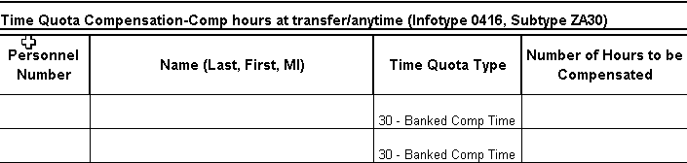
Personnel Number: Enter the IRIS-assigned personnel number(s) of employee(s). Please Note: The Payment of Banked Comp Time form allows for the entry of multiple employees. Please list each employee on a separate line.
Name (Last, First, MI): Enter the employee(s) name(s).
Time Quota Type: 30-Banked Comp Time (this will be defaulted in and may not be changed).
Number of Hours to be Compensated: Enter the number of banked comp time hours to be compensated.

Forward approved form to the Campus Payroll Office for processing.

