Student Assistant Short Form

After submitting a request to Human Resources (or Payroll) for information to be added, removed or changed on a person or position, it is a good practice to verify that the changes to the requested record have been entered correctly into the IRIS system. You should be able to verify the accuracy of most changes to person data by using transaction PA20 (Display HR Master Data) in the IRIS system. You should be able to verify the accuracy of most changes to position data by using transaction PO13 (Maintain Position) in the IRIS system. When requesting changes via a paper form, please allow ample time for the central office to enter the changes.

The Student Assistant Short Form is to be used to hire ONLY Student Assistants with ONE appointment. The form is designed to allow departments to hire several student assistants on one form. A W-4 form and I-9 documentation for each student assistant hired must accompany this form.

To complete the form, please provide the following information.

Responsible Cost Center Number: Enter the responsible cost center number (E account) of the student (also known as the primary cost center)
Responsible Cost Center Name: Enter the responsible cost center name of the student
Preparer: Enter the name of the person who prepared the form
Preparer’s Phone Number: Enter the phone number of the person who prepared the form
Date Prepared: Enter the date the form was prepared
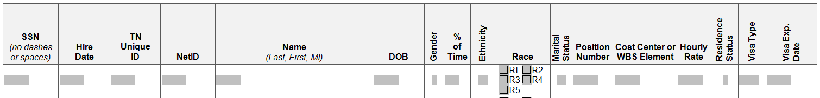

SSN: Enter the student assistant’s social security number
Hire Date: Enter the effective date of hire
TN Unique ID: Enter the student assistant’s 9-digit Tennessee Unique ID number. Use IRIS transaction ZSEV – Employee/Student Look-Up to find the TN Unique ID.
NetID: Enter the student assistant’s NetID. Use IRIS transaction ZSEV – Employee/Student Look-Up to find the NetID.
Name: Enter the student assistant’s last name, first name and middle initial
Date of Birth: Enter the student assistant’s date of birth
Gender: Enter the gender code for student assistant’s gender
Codes:
M-Male
F-Female
% of Time: Enter the percentage of time student assistant will be working
Ethnicity: Enter the appropriate code for Ethnicity
Codes:
E1-Hispanic/Latino
E2-Not Hispanic/Latino
Race: Place an X in the box beside the appropriate codes for the student assistant’s race (NOTE: Student assistants may identify more than one racial heritage. Check as many boxes as appropriate.)
Codes:
R1-American Indian or Alaskan Native
R2-Asian
R3-Black or African American
R4-Native Hawaiian or Other Pacific Islander
R5-White

Marital Status: Enter the marital status code for the student assistant’s marital status
Codes:
M-Married
S-Single
Position Number: Enter the position number the student assistant will be filling (NOTE: More than one student assistant may be assigned to a single position)
Cost Center or WBS Element to be Charged: Enter the appropriate Cost Center or WBS Element that will be paying the student assistant
Hourly Rate: Enter the hourly rate the student assistant will be paid
Residence Status: Enter the residence status code of the student assistant’s residence status
Codes:
C-Citizen
A-Non-resident Alien
N-Permanent Resident
Visa Type: Enter student assistant’s visa type, if applicable
Visa Exp Date: Enter the date the student assistant’s visa expires

