After submitting a request to Human Resources (or Payroll) for information to be added, removed or changed on a person or position, it is a good practice to verify that the changes to the requested record have been entered correctly into the IRIS system. You should be able to verify the accuracy of most changes to person data by using transaction PA20 (Display HR Master Data) in the IRIS system. You should be able to verify the accuracy of most changes to position data by using transaction PO13 (Maintain Position) in the IRIS system. When requesting changes via a paper form, please allow ample time for the central office to enter the changes.

The Personnel Change Form is to be used to record different changes that may occur to a person's status or pay while employed at the University. These changes may be transfers, changes in tenure status, or, in the case of Agriculture Extension staff, corporate function assignment changes.

To better track why a certain action is being taken, there are reasons for each action. The reasons are specific descriptors of the actions.

Section 1:

Section 1 records basic information about the employee and the person preparing the Personnel Change form. To complete, please enter the following:

Employee Name: Enter employee’s last name, first name and middle name.
Personnel Number: Enter the IRIS-assigned personnel number of employee.
Responsible Cost Center Enter the Cost Center (E Account) of the department initiating the change.
Cost Ctr Name: Enter the department's name.
Preparer: Enter the name of the person who prepared the Personnel Change form.
Phone#: Enter the phone number of the person who prepared the Personnel Change form.

Section 2:
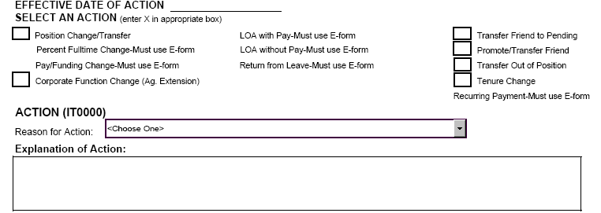

Section 2 is used to indicate the type of action to be taken, the effective date of the action, the reason for the action, and space to clarify the reason for the action if needed.

The Effective Date of Action is the first day the new information is to go into effect, such as the first day an employee begins working in a new position or the first day a new distribution of funding starts.

To begin the change, check the appropriate Action and corresponding Reason for Action. Listed below are the Actions with a brief explanation, and the corresponding Reasons for Action. For a quick review of the sections of the Personnel Change form to be completed for each Action, please see Appendix A.

Position Change/Transfer

The Position Change/Transfer Action is to be checked if the employee is (1) transferring to another position on his/her current campus; (2)adding or removing a position; (3) changing from a 9-month to a 12-month appointment or from a 12-month to a 9-month appointment; (4) changing Employee Groups; (5) changing Payroll Areas; (6) receiving a job reclassification in his/her current position; or (7) changing between scheduled pay to special or between special to scheduled pay. Although other actions should not be marked, changes may be made to an employee's percentage of time, distribution of pay, and planned working time on the Change Form during a Position Change/Transfer Action.

The following are the corresponding Reasons for Action for the Position Change/Transfer Action. Choose from the following list:

Add a Position | Lateral Transfer
Change Between 9-month & 12-month | Organizational Unit Change
Change to Regular | Payroll Area Change
Change to Student | Promotion
Change to Temp | Remove a Position
Demotion | Scheduled Pay to Special
Error Correction | Special to Scheduled Pay
Interim/Action Add-Remove | Student Transfer
Job Reclassification | Temp Transfer
Corporate Function Change | Promote/Transfer Friend
Tenure Change | Transfer Friend to Pending Emp
Transfer Out of Position

Percent Fulltime Change

The Percent Fulltime Change Action may be performed only by an IRIS e-form (Transaction ZPPAY000 – Personnel Change Request)

Pay/Funding Change

The Pay/Funding Change Action may be performed only by an IRIS E-form (Transaction ZPPAY000 – Personnel Change Request).

Corporate Function Change (Ag. Extension)

The Corporate Function Change Action is to be used when an Ag Extension employee needs to change either his/her area of responsibility or the percentage of time dedicated to multiple areas of responsibility.

The ONLY corresponding Reason for Action for a Corporate Function Change is

Corporate Function Change

LOA with Pay

The LOA with Pay Action may be performed only by an IRIS E-form (Transaction ZPPAY000 – Personnel Change Request).

LOA without Pay

The LOA without Pay Action may be performed only by an IRIS E-form (Transaction ZPPAY000 – Personnel Change Request).

Return from Leave

The Return from Leave Action may be performed only by an IRIS E-form (Transaction ZPPAY000 – Personnel Change Request).

Transfer Friend to Pending

The Transfer Friend to Pending Action is used when a person who is currently in the Employee Group of Friend of UT is being hired in a Pending status. When a Friend is being transferred from the Pending status to either a regular, temporary, or student employee, please use the Initial Hire/Rehire form.

The ONLY corresponding Reason for Action for a Transfer Friend to Employee Action is

Transfer Friend to Pending Emp

Promote/Transfer Friend

The Promote/Transfer Friend Action is used when a person who is currently in the Employee Group Friend of UT is transferring to another position, but remaining in the Friend of UT Employee Group.

The ONLY corresponding Reason for Action for a Promote/Transfer Friend Action is

Promote/Transfer Friend

Transfer Out of Position

The Transfer Out of Position is to be used ONLY when an employee is transferring to a different campus (i.e., Memphis to Martin, Knoxville to Chattanooga). This does not apply to employees who may transfer to a different Personnel Area in the Knoxville area. This allows the data entry person at the receiving campus to access the transferring person so he/she may perform the Position Change/Transfer Action.

The ONLY corresponding Reason for Action for a Transfer Out of Position Action is

Transfer Out of Position

Tenure Change

The Tenure Change Action is to be used to record a change in tenure for a faculty member. The change could be a change in status, tenure college, tenure department, date tenure was granted (or the initial entry of date tenure was granted), tenure review date (or removal of the tenure review date), academic rank, and the change of academic rank date. The Tenure Change Action may be combined with other actions on the same Personnel Change form.

The ONLY corresponding Reason for Action for a Tenure Change Action is

Tenure Change

Add Recurring Payment

The Add Recurring Payment Action may be performed only by an IRIS E-form (Transaction ZPRECPAY000).

An Explanation of Action box is available for the department to enter any additional information that might be pertinent to the action being taken.
Section 3:

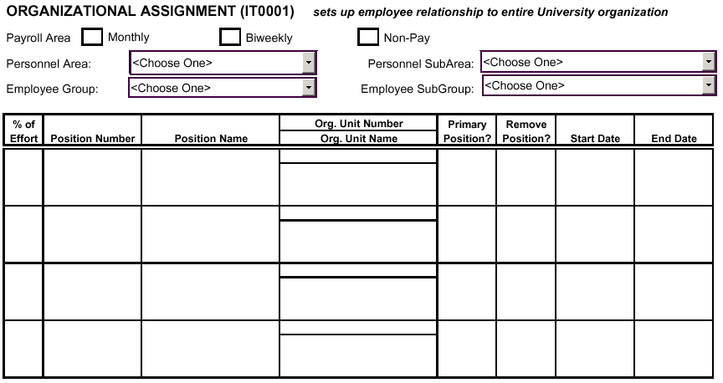

Section 3 records changes in the employee's relationship to the University.

The Payroll Area is the indicator of the pay cycle the employee will have.

Monthly: Check if the employee is to be paid on the monthly payroll.
Biweekly: Check if the employee is to be paid on the biweekly payroll.
Non-Pay: Check if the employee will not be receiving regular pay from the University or will be on a Special Appointment.

The Personnel Area identifies the major organizational divisions of the University. Choose the
appropriate Personnel Area from the following:

Chattanooga Memphis
Institute for Public Service Space Institute
Institute of Agriculture University Administration
Knoxville UT Medical Center
Martin

The Personnel Subarea is a further breakdown within the Personnel Area. Choose the appropriate Personnel Subarea from the following:

Personnel Area | Personnel Subarea
Chattanooga | Chattanooga
Institute for Public Service | CTAS
Institute for Public Service | IPS
Institute for Public Service | MTAS
Institute of Agriculture | Agriculture Experiment Station
Institute of Agriculture | Extension
Institute of Agriculture | Extension - Fed
Institute of Agriculture | Veterinary Medicine
Knoxville | Athletics
Knoxville | Knoxville
Martin | Martin
Memphis | Bowld Hospital
Memphis | Clinical Chattanooga
Memphis | Clinical Knoxville
Memphis | Family Practice-Jackson
Memphis | Family Practice-Knoxville
Memphis | Family Practice-Memphis
Memphis | Research Center
Space Institute | Space Institute
University Administration | University Administration
UT Medical Center | Medical Center

The Employee Group is the category of the employee. Combined with the percentage of time the employee works and the Employee Subgroup, the Employee Group sets the employee's eligibility for benefits, including leave accrual. The choices for Employee Group are as follows:

Regular Student
Temporary Friend

The Employee Subgroup is the designation of the employee. The designation indicates whether the employee completes a biweekly or monthly timesheet, whether a faculty member has a 9-month or 12-month appointment, or whether an exempt employee is in an Executive/ Administrative or Professional position. The type of Employee Subgroup an employee may have is dependent upon the employee's Employee Group. The choices for the Employee Subgroup are as follows:

Friends of UT - Affiliated Regular - Faculty 12month
Friends of UT - Board of Trustees Regular - Faculty 9month
Friends of UT - Clinical Regular - Staff: Exec/Admin (exempt)
Friends of UT - Honorary Regular - Staff: Hourly Input (biweekly)
Friends of UT - Non Clinical Regular - Staff: Hourly NoInput (monthly)
Friends of UT - Traveler Regular - Staff: Professional (exempt)
Friends of UT - Volunteer

Student - GradStu: Salary 12mth Temp - Faculty 12month
Student - GradStu: Salary 9mth Temp - Faculty 9month
Student - Medical Intern/Resident Temp - Special Appointment (no pay)
Student - Std: Fellow/Trainee Temp - Staff: Exec/Admin (exempt)
Student - Std: Hourly Input Temp - Staff: Hourly Input (biweekly)
Student - Std: Hourly NoInput Temp - Staff: Hourly NoInput (monthly)
Temp - Staff: Professional (exempt)

Complete the chart to reflect the changes that will be occurring as a result of the Personnel Change Form. In the case of a Position Change/Transfer, the department will put the new information in the first row and the other position(s) in the lower rows.

Enter the following information to complete the Organizational Assignment section of the Personnel Change form.

% of Effort: Enter the percent of time the employee is assigned to the position. The total of this column will equal the employee's Total Employee Percentage of Effort that will be entered in the Planned Working Time section.
Position Number: Enter the 8-digit IRIS-assigned ID number.
Position Name: Enter the name of the position.
Org. Unit Number: Enter the 8-digit IRIS-assigned ID number.
Org. Unit Name: Enter the department's name.
Primary Position?: Indicate if the position is the primary position by entering Y for yes, or N for no.
The Primary Position determines where the employee's check advice will be sent. If the employee has only one position, it is automatically designated as the Primary Position. If an employee has more than one position, the position with the greatest percent of time attached to it is designated as the Primary Position. If the employee has more than one position and the percent of time is evenly distributed between the multiple positions, then the first position entered into IRIS is designated as the Primary Position.
Remove Position? Indicate if the employee is to be removed from the position by entering Y for yes, or N for no.
Start Date: Enter the first day the employee is to be in the position (or was put in the position).
End Date: Enter the last day the employee is to be in the position (or was in the position).

Section 4:
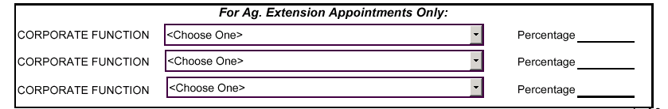

Section 4 is to be used for Agriculture Extension appointments only. The Corporate Function indicates the employee's area of responsibility. Enter the appropriate Corporate Function and the percentage employee will be assigned to the Corporate Function. The Corporate Function options are as follows:

4-H Youth Development | Executive Administrative | Resource Development
Agriculture & Natural Resources | Family & Consumer Sciences | Organizational Support

Section 5:

Section 5 is the beginning of page 2 of the Personnel Change form.

Employee Name: Employee’s Name will automatically be completed,
based on the information on page 1 of the form.
Personnel Number #: Employee’s Personnel Number (if applicable) will automatically be completed, based on the information on page 1 of the form.

Section 6:
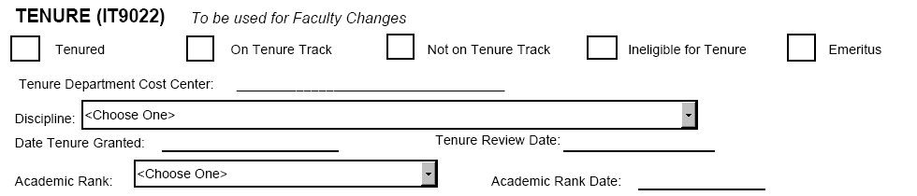

Section 6 is to be used to record a change in tenure for a faculty member. The change could be a change in status, tenure college, tenure department, date tenure was granted (or the initial entry of date tenure was granted), tenure review date (or removal of the tenure review date), academic rank, and the change of academic rank date.

To complete the changes to a faculty member's Tenure information, enter the following information:

Tenure: Check if faculty member has tenure or is receiving tenure.
On Tenure Track: Check if faculty member is on tenure track.
Not of Tenure Track: Check if faculty member is not on tenure track.
Ineligible for Tenure: Check if faculty member is not eligible for tenure.
Emeritus: Check if faculty member or chief administrator has been granted emeritus status.

Tenure Department Cost Center: Enter the cost center (E Account) of the department that will grant the tenure. The cost center will automatically determine the location, college, and department.

Discipline: Select the faculty member’s discipline from the choices listed in the drop-down. The format for the Discipline is Name of Discipline (Code).

Date Tenure Granted: Enter date tenure was granted, if applicable.
Tenure Review Date: Enter date tenure is to be reviewed, if applicable.
Academic Rank: Enter the appropriate academic rank. The options for Academic Rank are as follows:
Assistant Professor
Associate Professor
Instructor
Lecturer
Professor
Academic Rank Date: Enter the date Academic Rank was received.

Section 7

When an employee transfers from one department to another, the department the employee is leaving is responsible for paying off any comp hours that have been banked. In addition, there may be an occasion when a department will be responsible for paying out an employee's annual leave balance. Section 7 is used to record the number of compensatory and/or annual leave hours to be paid at the time an employee transfers.

To determine the number of hours to compensate employee, complete the following steps:

1. Review the quota overview (transaction PT50). The quota overview may be accessed by the following path:

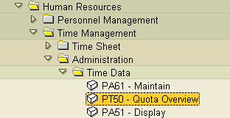

2. Enter employee's Personnel Number to retrieve Quota Overview.

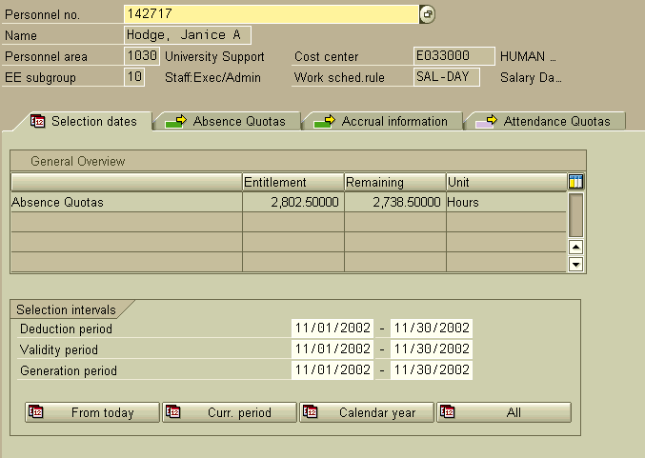

3. Click on the Absence Quotas tab. The following screen will be displayed.
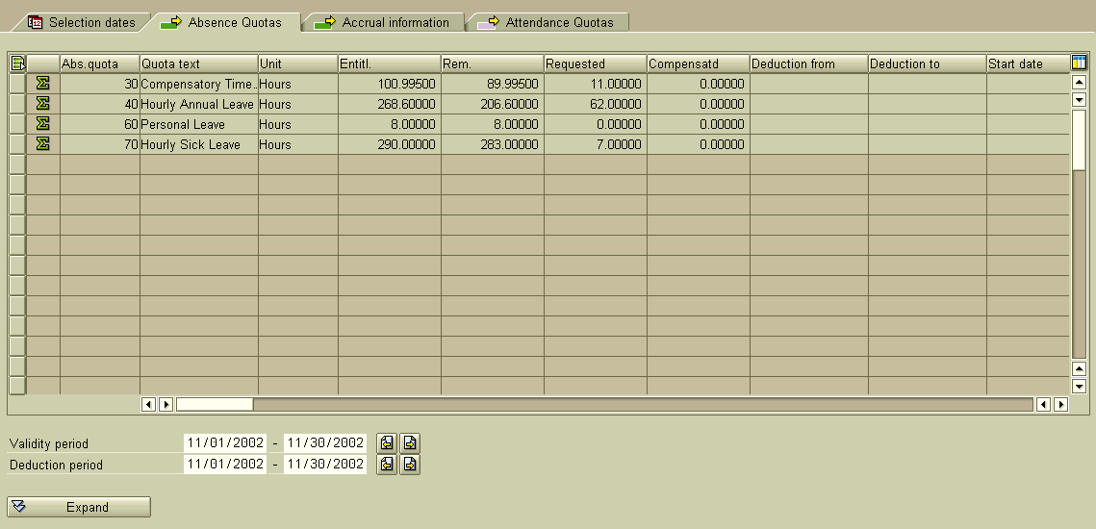

4. The current balance (as of the first of the month) is displayed in the column titled Rem.

5. The Comp Hours balance will need to be adjusted by deducting the number of hours taken in the current pay period from the balance shown. Enter the adjusted number of Comp Hours to be compensated on the Termination form.

6. If the employee is transferring in the middle of the month, the Annual Leave balance will have to be adjusted in the following manner:

Deduct number of hours taken in the current pay period.
Adjust accrual rate for month employee is leaving since a full-month accrual has already been included in the current balance.

6a. To adjust accrual rate for month employee is transferring, make the following calculation:

Divide the number of days worked in the month by the number of days available to work to get the percentage of accrual the employee should receive.

6b. Subtract the normal accrual rate from the current balance. Add the partial accrual rate to the current balance and deduct any leave taken that has not been recorded.

(Current balance − Normal accrual rate + Partial accrual rate − Unrecorded leave) = Adjusted leave balance to be compensated.

6c. Enter the adjusted leave balance on the Personnel Change form.

Section 8:

The Planned Working Time indicates the work schedule of the employee. The options for the Work Schedule Rule are as follows:

Work Schedule Rule | Explanation
F31A-Sal | Ag Exp Sta (Branch Stations) employee who works a 40 hour week
F31B-Sal | Ag Exp Sta (Branch Stations) employee who works a 43 hour week
F31C-Sal | Ag Exp Sta (Branch Stations) employee who works a 45 hour week
Flex-Day | Employee on a flex-year schedule (works day shift)
Flex-2nd | Employee on a flex-year schedule (works 2nd shift)
Flex-3rd | Employee on a flex-year schedule (works 3rd shift)
Hour-Day | Hourly Input employee (works day shift)
Hour-2nd Shift | Hourly Input employee (works 2nd shift)
Hour-3rd Shift | Hourly Input employee (works 3rd shift)
NonPay | Used for Friends and Travelers
Sal-Day | Hourly NoInput employee (works day shift),Exec/Admin, Faculty, Professional
Sal-2nd Shift | Hourly NoInput employee (works 2nd shift)
Sal-3rd Shift | Hourly NoInput employee (works 3rd shift)
Special-Schedule Attached | Employees on either SAL-DAY, SAL-2nd SHIFT, or SAL-3rd SHIFT whose schedule is not a normal M-F, 8-5)

Section 9:
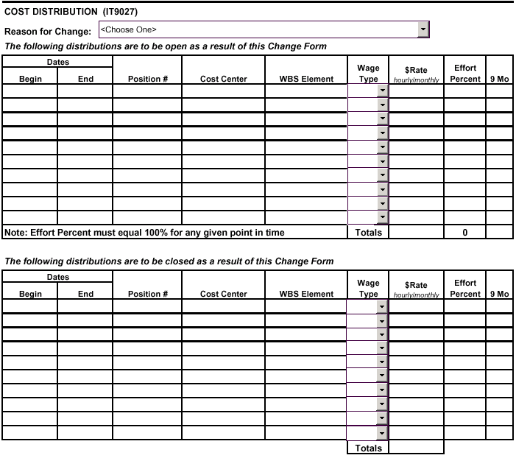

Section 9 reflects the funding sources that will pay the employee, the type of pay each distribution represents, the hourly or monthly rate of pay, the percent of effort the employee will expend to each funding source, and if the position is a 9-month appointment. To complete the Cost Distribution section, enter the following information:

Reason for Change

The Reason for Change explains specifically why an employee's pay or funding source is to be changed. Although independent from the Actions, the Reason for Change will logically follow certain Actions. Listed below are the Reasons for Change with the Actions that most likely correspond to the Reasons for Change.

Reason for Change | Related Actions
Add a Position | Position Change/Transfer
Change in Pay Cycle-No Increase | Position Change/Transfer
Change to Regular | Position Change/Transfer
Change to Student | Position Change/Transfer
Change to Temporary | Position Change/Transfer
Conversion of Academic Salary | Position Change/Transfer
Demotion to Vacant Position | Position Change/Transfer
Error Correction | All
Increase-Responsibilities | Position Change/Transfer
Job Reclassification or Audit | Position Change/Transfer
Lateral Transfer to Vacant Position | Position Change/Transfer
Promotion in Place | Position Change/Transfer
Promotion to Vacant Position | Position Change/Transfer
Remove a Position | Position Change/Transfer
Student Change | Position Change/Transfer

The first chart in the Cost Distribution section is to be used to record ALL distributions that will be open after the Action is completed. This includes those distributions that will have no change, but will remain open. Enter the following information for the OPEN distributions:

Begin Date: Enter date distribution is to begin.
End Date: Enter date distribution is to end.
Position #: Enter IRIS-assigned position identification number (enter position number for each line, even if split funding is for same position). If a Create Position form is being submitted with the Personnel Change form, leave position number blank for position to be created. The Campus Human Resources/Personnel office will enter the position number after it has been created.
*Cost Center: The Cost Center is associated with state and auxiliary funds (E accounts). Enter cost center number funding position, if applicable.
*WBS Element: The WBS Element is associated with grant, contract, or gift funding (R accounts). Enter WBS element funding position, if applicable.

*Please Note: A Cost Center distribution and a WBS Element distribution cannot be on the same line, even if it is an even split. A separate line must be completed for each funding source.

The Wage Type describes what type of earnings each distribution represents. Choose from the following options:

1ADA - Administrative Assignment  1ALU – Distinguished Professor | 1PRT – Professorship-Temp  1REG – Regular (Monthly)
1FEL - Taxable Fellowship  1FPY – Payment Outside US | 1RGA - Reg Pay from Agency  1STP – Taxable Stipend
1HRL – Base Hourly Rate (Biweekly) | 2AGY - Agency Pay
1LIV – Living Expense | 2IPR - Insurance-Post Retirement
1PRP – Professorship-Perm | 2SNP - Special Non-Pay

Rate: Enter hourly OR monthly rate of pay. (NOTE: Employees cannot have both an hourly and a monthly rate of pay).
Effort Percent: The Effort Percent is the indicator of how much effort the employee spends working on each distribution (Cost Center or WBS Element). Enter the percentage of effort of time employee is expending on each Cost Center/WBS Element listed. The total of these percentages must equal 100%. (Ex. A single funding source would be 100%; two funding sources may be any combination of percentages equaling 100%). If the employee's percentage of effort as entered on the Planned Working Time section is less than 100%, the total effort percent for the cost distributions must still equal 100%.
9 Mo: Check if position is a nine (9) month appointment.

Repeat for each distribution if the employee receives funding from more than one source.

If the person has been checked as being in the Monthly Payroll Area (Pay Cycle), the total monthly amount will automatically be calculated in the TOTALS section. Also, the total percent of effort will be calculated in the TOTALS section. Please Note: The total percent of effort must equal 100.

The second chart in the Cost Distribution section is to be used to record any distributions that may be closed after the Action is completed. Complete this chart by entering the required information. Explanations of each field is listed above. Please Note: The Effort Percent column does not have to be calculated in this section.

Section 10:

Section 10 is the beginning of page 3 of the Personnel Change form.

Employee Name: Employee’s Name will automatically be completed,
based on the information on page 1 of the form.
Personnel Number #: Employee’s Personnel Number (if applicable) will automatically be completed, based on the information on page 1 of the form.

Section 11

Section 11 provides the procedure to be followed for changing a position.

Section 12:

For Approval Signatures, follow the guidelines set forth by your Campus/Institute.
Appendix A

Action | Sections to be Completed
 | Organizational Assignment | Corporate Function | Tenure | Time Quota Compensation | Planned Working Time | Cost Distribution
Position/Change Transfer | X |  | X* | X** | X*** | X
Corporate Function Change | X | X
Transfer Friend to Pending | X**** | X* |  |  | X******
Promote/Transfer Friend | X | X* | X* |  | X | X
Transfer Out of Position | X |  |  |  |  | X
Tenure Change | X |  | X |  |  | X*
* If applicable
** If leave needs to be paid at transfer
*** If Planned Working Time is changing
**** Must be a “Pending Employee Position
***** Must be Non-Pay

