Family/Related Person Form

After submitting a request to Human Resources (or Payroll) for information to be added, removed or changed on a person or position, it is a good practice to verify that the changes to the requested record have been entered correctly into the IRIS system. You should be able to verify the accuracy of most changes to person data by using transaction PA20 (Display HR Master Data) in the IRIS system. You should be able to verify the accuracy of most changes to position data by using transaction PO13 (Maintain Position) in the IRIS system. When requesting changes via a paper form, please allow ample time for the central office to enter the changes.

The Family/Related Person Form is used to record spouse and dependent children information. This information will be used for Fee Discounts and Flexible Spending Accounts.

To complete the form, please provide the following information.
Employee Name: Enter employee’s last name, first name and middle initial.
Personnel Number: Enter the IRIS-assigned personnel number of employee.
SSN#: Enter the social security number of the employee .
Responsible Cost Ctr#: Enter the responsible cost center number (E account) of the employee (also known as the primary cost center).
Effective Date: Enter date change is to be made effective.
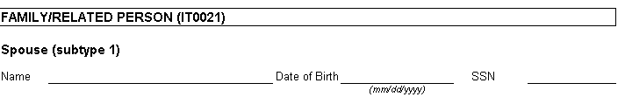
Name: Enter full name of spouse.
Date of Birth: Enter spouse’s date of birth (optional).
SSN: Enter spouse’s social security number.
Name: Enter full name of child.
Date of Birth: Enter child’s date of birth (required).
SSN: Enter child’s social security number.

Repeat this information for each child.

